**Indian Ocean**

**When to travel** Home to a variety of stunning destinations, each of which enjoys some of the world’s finest weather. In Mauritius weather is varied, with cloudy skies giving way to bright sunshine in a matter of minutes, making it a great year round holiday destination. In the Maldives the hottest month is April and the coldest is December, while in Mauritius the best time to visit is November to April. In the Seychelles the temperature rarely falls below 230 and Sri Lanka enjoys the best weather on the west and south coast between December and March.

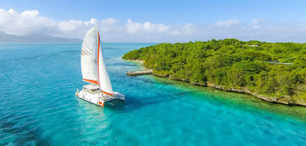Magical **Mauritius** Cast away to a beautiful, palm-fringed island where tranquil beaches give way to dramatic, volcanic landscapes. Imagine yourself relaxing on the island of Mauritius where you’ll be treated to captivating natural surroundings and colourful villages, world-class hotels and some of the best watersport facilities in the Indian Ocean. From the hustle and bustle of the island’s capital Port Louis to the tranquil Black River Gorges National Park, Mauritius is a destination with something for everyone. History, culture, white sandy beaches, amazing sports facilities and year-round tropical climate make it an A-list destination. The food in Mauritius is not to be missed, from traditional French-Creole melting pots to freshly caught seafood, exotic fruit to tasty grilled-on-the-beach barbeques, food on Mauritius reflects all elements of the island’s character – diversity, richness and colour.

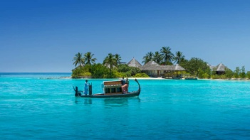Dive into the **Maldives** The beautiful Maldives scattered across the Indian Ocean open up a world of opportunity for travellers who want to embark upon a personal adventure full of stunning beaches, mouth-watering food and first-class service. The Maldives are a range of coral reefs which developed around the sides of ancient volcanoes and remained on the ocean surface once the rock formations had sunk. What’s left is a remarkable selection of islands offering white sands, clear bright blue seas and endless sunshine. The Maldives are recognised as one of the best destinations in the world for snorkelling and diving. With thousands of different types of colourful fish darting in and out of the protected coral reefs, you’ll never be short of something new to spot. Ship wrecks and reef walls give the more experienced diver something truly special to explore.

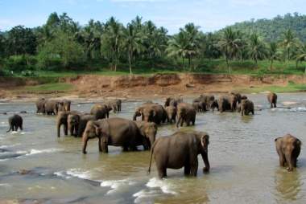Simply spectacular **Sri Lanka** Just off the east coast of India lies the island of Sri Lanka, tear shaped, with beautiful beaches, lush rainforests, exotic wildlife and stunning mountain views. Holding the record for the most UNESCO World Heritage Sites in a small area, Sri Lanka boasts eight of the accolades. The island has been inhabited for more than 2,000 years, yet only now is it becoming a ‘go to’ destination. Temples, ancient artefacts, fine colonial buildings, plantation communities, rural idylls and rainforest residences can all be found on Sri Lanka, where natives live side by side with elephants, water buffalo, monkeys, leopards and birds. Colombo, the island’s largest city, is a wonderful place to begin a trip to Sri Lanka and offers a hint of the past whilst looking keenly to the future. Capture the essence of Sri Lanka in Colombo, as you drink in the clashing colours and cultures of this stunning island.

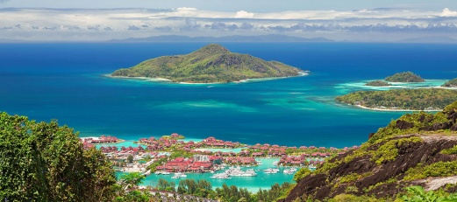Island escapes in **Seychelles** The Seychelles simply exude spirit and serenity and the small archipelago in the western Indian Ocean is deliciously remote, brimming with picture-perfect beaches and is quite simply a taste of paradise. Whether it’s for a honeymoon or a trip to celebrate children flying the nest, the Seychelles is the perfect choice.